1. Add the PETSTEP and CERR to your Matlab path.
2. Generate a folder with CT and PT subfolders containing the slices data.
3. Generate plan by typing 'CERR' - > choose DICOM deprecated -> choose CT and PT parent folder -> save the plan file as 'plan':

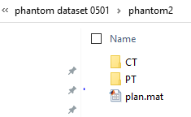

1. From here on you can use the example wrapper to load plan in CERRViewer and start the simulation.